INTRODUCTION

The design and implementation of a Complex Arithmetic Unit (CAU) play a crucial role in digital VLSI systems, as such units are essential for performing computationally intensive tasks involving complex numbers. This project focuses on designing a robust CAU capable of executing complex multiplication and complex addition with high precision and efficiency. The unit operates on 16-bit signed inputs and delivers the results within a single clock cycle, leveraging techniques like pipelining and synchronization to optimize performance.

The implementation explores two configurations: one utilizing four multipliers for maximum throughput and another optimized to use only three multipliers while maintaining efficiency. To ensure functional correctness and synchronization, a comprehensive testbench with automated verification logic is developed. The design is evaluated based on accuracy, timing requirements, resource utilization, and compliance with single-cycle operation constraints. By adhering to these objectives, the project aims to provide a high-performance, resource-efficient solution for complex arithmetic operations in modern VLSI systems.

ABSTRACT

This project presents the design and development of a Complex Arithmetic Unit (CAU) for performing critical operations, including complex multiplication and addition, on 16-bit signed inputs. The CAU is engineered to produce results in a single clock cycle, utilizing a pipelined architecture to enhance performance. The implementation explores two configurations, leveraging four and three multipliers, respectively, to achieve optimal trade-offs between throughput and resource efficiency. Comprehensive testing and validation are conducted using an automated testbench to ensure functional correctness and synchronization. This work demonstrates a practical approach to designing high-performance VLSI systems for computationally intensive applications.

WORKING

The VLSIOEL unit is based on a pipelined architecture that separates the computation into multiple stages, enabling efficient processing of multiple operations simultaneously. The main stages of the pipeline are as follows:
1. Stage 1: Partial Products
The partial products for the multiplication are calculated based on the configuration of the multiplier. If `use_3_multipliers` is set to 1, three products (p1, p2, p3) are computed based on the inputs `a`, `b`, `c`, and `d`. Otherwise, four partial products (ac, bd, ad, bc) are computed for the 4-multiplier configuration.
2. Stage 2: Final Results
The final results of the multiplication (`y_stage`, `z_stage`) are calculated based on the partial products. Additionally, the addition results (`w_stage`, `x_stage`) are computed as simple sums of `a + c` and `b + d`.

3. Output Stage
The final results are assigned to the output registers `y`, `z`, `w`, and `x` upon completion of the computation. The `valid` signal is asserted when the output is ready.

The design leverages pipelining to ensure that multiple operations can be performed concurrently, improving throughput and overall performance. The use of different multiplier configurations (3-multiplier or 4-multiplier) provides flexibility in terms of resource utilization and parallelism.

OPERATIONS PERFORMED

The pipelined complex arithmetic unit supports the following operations:

1. Multiplication of Complex Numbers:
When using four multipliers, the unit computes the product of two complex numbers:
y = ac - bd (real part)
z = ad + bc (imaginary part)

2.Addition of Complex Numbers:
The unit computes the sum of the real and imaginary parts:
w = a + c (real part)
x = b + d (imaginary part)

3. Three-Multiplier Configuration:
In this configuration, the multiplication operation is optimized to use fewer multipliers by performing a combination of partial products:
• p1=a×c
• p2=b×d
• p3=(a+b)×(c+d)

The final multiplication results are derived from the partial products.

PIPELINED DESIGN

The pipelined design of the code allows for efficient processing of complex arithmetic operations by breaking down the task into multiple stages. This enables the unit to compute different operations concurrently, improving throughput and reducing latency. The pipelining stages ensure that intermediate results are stored and reused in subsequent cycles, allowing the design to handle multiple operations in parallel. The separation of multiplication and addition operations into distinct stages also enhances modularity and simplifies debugging and testing.

SIMULATION RESULTS

The design was tested with several test cases to ensure correct operation under different conditions. The test cases include:

1. Test Case 1: Simple Inputs
Inputs: `a = 1`, `b = 2`, `c = 3`, `d = 4`
Output (4-multiplier):
Multiplication: `y = -5`, `z = 10`
Addition: `w = 4`, `x = 6`

2. Test Case 2: Negative Values
Inputs: `a = -5`, `b = -6`, `c = 7`, `d = -8`
Output (4-multiplier):
Multiplication: `y = 43`, `z = 2`
Addition: `w = 2`, `x = -14`
Output (3-multiplier):
Same results for multiplication and addition.

3. Test Case 3: Edge Cases (Overflow Scenario)
Inputs: `a = 32767`, `b = -32768`, `c = 32767`, `d = -32768`
Output (4-multiplier):
Multiplication: `y = 0`, `z = 0` (overflow handled implicitly)
Addition: `w = -1`, `x = -1`
Output (3-multiplier):
Same results for multiplication and addition.

4. Test Case 4: Zero Values
Inputs: `a = 0`, `b = 0`, `c = 0`, `d = 0`
Output (4-multiplier):
Multiplication: `y = 0`, `z = 0`
Addition: `w = 0`, `x = 0`
Output (3-multiplier):
Same results for multiplication and addition.

5.Test Case 5: Mixed Positive and Negative Values
Inputs: `a = 10`, `b = -5`, `c = 2`, `d = -3`
Output (4-multiplier):
Multiplication: `y = 70`, `z = 5`
Addition: `w = 12`, `x = -8`
Output (3-multiplier):
Same results for multiplication and addition.

SIMULATION WAVE
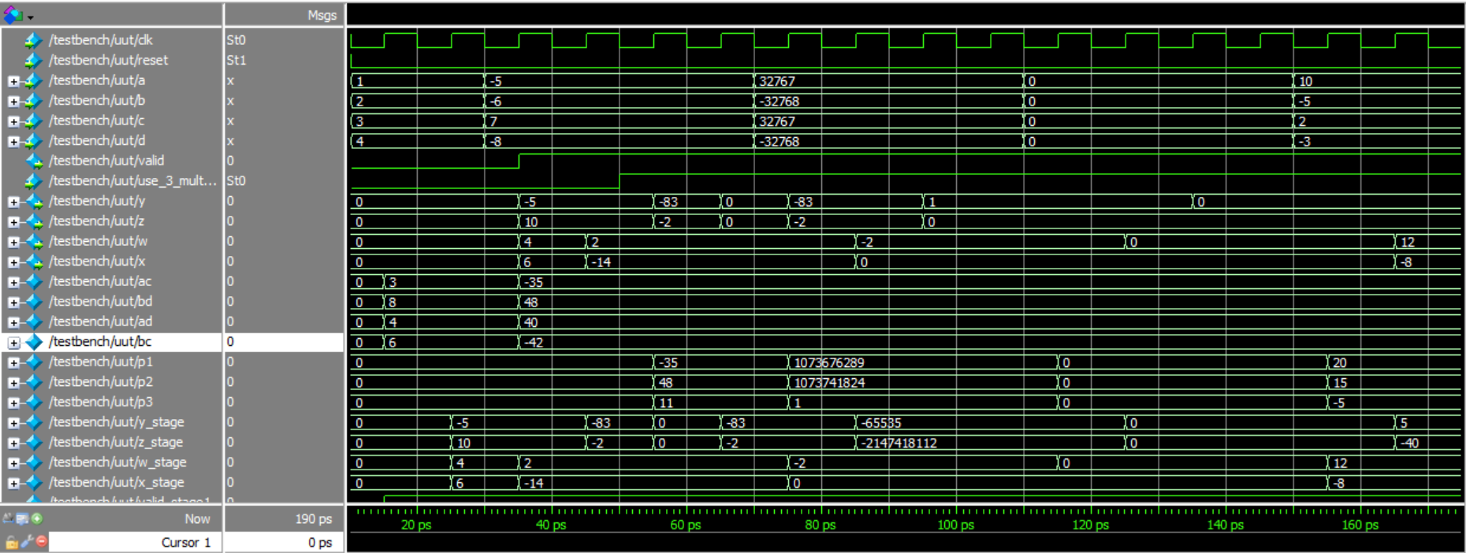

CONCLUSION

The VLSIOEL pipelined complex arithmetic unit provides an efficient solution for performing arithmetic operations on complex numbers. The use of pipelining allows the unit to operate with high throughput, and the flexibility to switch between 3-multiplier and 4-multiplier configurations allows for optimization of resources. The simulation results confirm that the design correctly handles a wide range of input values, including edge cases like overflow, and produces the expected results for both multiplication and addition of complex numbers.

CODE

module VLSIOEL (  input clk, reset, // Clock and Reset  input signed [15:0] a, b, c, d, // Inputs: Real and Imaginary parts  input use_3_multipliers, // Control signal to select multiplier configuration  output reg signed [15:0] y, z, //Multiplication result  output reg signed [15:0] w, x, // Addition result  output reg valid // Result valid signal  );  // Pipeline registers for intermediate results  reg signed [31:0] ac, bd, ad, bc; // Stage 1: Partial products (4-multiplier)  reg signed [31:0] p1, p2, p3; // Stage 1: Partial products (3-multiplier)  reg signed [31:0] y_stage, z_stage; // Stage 2: Final results  reg signed [15:0] w_stage, x_stage; // Stage 2: Addition results  reg valid_stage1, valid_stage2;  // Stage 1: Partial products  always @(posedge clk or posedge reset) begin  if (reset) begin  ac <= 0; bd <= 0; ad <= 0; bc <= 0;  p1 <= 0; p2 <= 0; p3 <= 0;  valid_stage1 <= 0;  end else begin  if (use_3_multipliers) begin  // 3-multiplier configuration  p1 <= a * c;  p2 <= b * d;  p3 <= (a + b) * (c + d);  end  else begin  // 4-multiplier configuration  ac <= a * c;  bd <= b * d;  ad <= a * d;  bc <= b * c;  end  valid_stage1 <= 1;  end  end | // Stage 2: Final results  always @(posedge clk or posedge reset) begin  if (reset) begin  y_stage <= 0; z_stage <= 0; w_stage <= 0; x_stage <= 0;  valid_stage2 <= 0;  end  else if (valid_stage1)  begin  if (use_3_multipliers)  begin  // 3-multiplier final results  y_stage <= p1 - p2; // Real part of multiplication  z_stage <= p3 - p1 - p2; // Imaginary part of multiplication  end  else begin  // 4-multiplier final results  y_stage <= ac - bd; // Real part of multiplication  z_stage <= ad + bc; // Imaginary part of multiplication  end  w_stage <= a + c; // Real part of addition  x_stage <= b + d; // Imaginary part of addition  valid_stage2 <= 1;  end  end  // Output stage  always @(posedge clk or posedge reset) begin  if (reset) begin  y <= 0; z <= 0; w <= 0; x <= 0;  valid <= 0;  end else if (valid_stage2) begin  y <= y_stage[15:0];  z <= z_stage[15:0];  w <= w_stage;  x <= x_stage;  valid <= 1;  end  end  endmodule
TESTBENCH

module testbench;  reg signed [15:0] a, b, c, d;  reg clk, reset, use_3_multipliers;  wire signed [15:0] y, z, w, x;  wire valid;  // Instantiate the pipelined complex arithmetic unit  VLSIOEL uut (  .clk(clk),  .reset(reset),  .a(a),  .b(b),  .c(c),  .d(d),  .use_3_multipliers(use_3_multipliers),  .y(y),  .z(z),  .w(w),  .x(x),  .valid(valid)  );  // Clock generation  initial clk = 0;  always #5 clk = ~clk;  // Test sequence  initial begin  reset = 1;  use_3_multipliers = 0;  #10 reset = 0;  // Test Case 1: Simple inputs  a = 16'd1; b = 16'd2; c = 16'd3; d = 16'd4;  #20;  $display("4-multiplier TC1 - y=%d, z=%d, w=%d, x=%d, valid=%b", y, z, w, x, valid);  // Test Case 2: Negative values  a = -16'd5; b = -16'd6; c = 16'd7; d = -16'd8;  #20;  $display("4-multiplier TC2 - y=%d, z=%d, w=%d, x=%d, valid=%b", y, z, w, x, valid);  // Switch to 3-multiplier configuration  use_3_multipliers = 1;  #20;  $display("3-multiplier TC2 - y=%d, z=%d, w=%d, x=%d, valid=%b", y, z, w, x, valid); | // Test Case 3: Edge cases (overflow scenario)  a = 16'd32767; b = -16'd32768; c = 16'd32767;  d = -16'd32768;  #20;  $display("4-multiplier TC3 - y=%d, z=%d, w=%d, x=%d, valid=%b", y, z, w, x, valid);  // Switch to 3-multiplier configuration  use_3_multipliers = 1;  #20;  $display("3-multiplier TC3 - y=%d, z=%d, w=%d, x=%d, valid=%b", y, z, w, x, valid);  // Test Case 4: Zero values  a = 16'd0; b = 16'd0; c = 16'd0; d = 16'd0;  #20;  $display("4-multiplier TC4 - y=%d, z=%d, w=%d, x=%d, valid=%b", y, z, w, x, valid);  // Switch to 3-multiplier configuration  use_3_multipliers = 1;  #20;  $display("3-multiplier TC4 - y=%d, z=%d, w=%d, x=%d, valid=%b", y, z, w, x, valid);  // Test Case 5: Mixed positive and negative  a = 16'd10; b = -16'd5; c = 16'd2; d = -16'd3;  #20;  $display("4-multiplier TC5 - y=%d, z=%d, w=%d, x=%d, valid=%b", y, z, w, x, valid);  // Switch to 3-multiplier configuration  use_3_multipliers = 1;  #20;  $display("3-multiplier TC5 - y=%d, z=%d, w=%d, x=%d, valid=%b", y, z, w, x, valid);  // Finish simulation  $finish;  end  endmodule

